SpecFlow – Feature Test – Property Owner : List A Rental

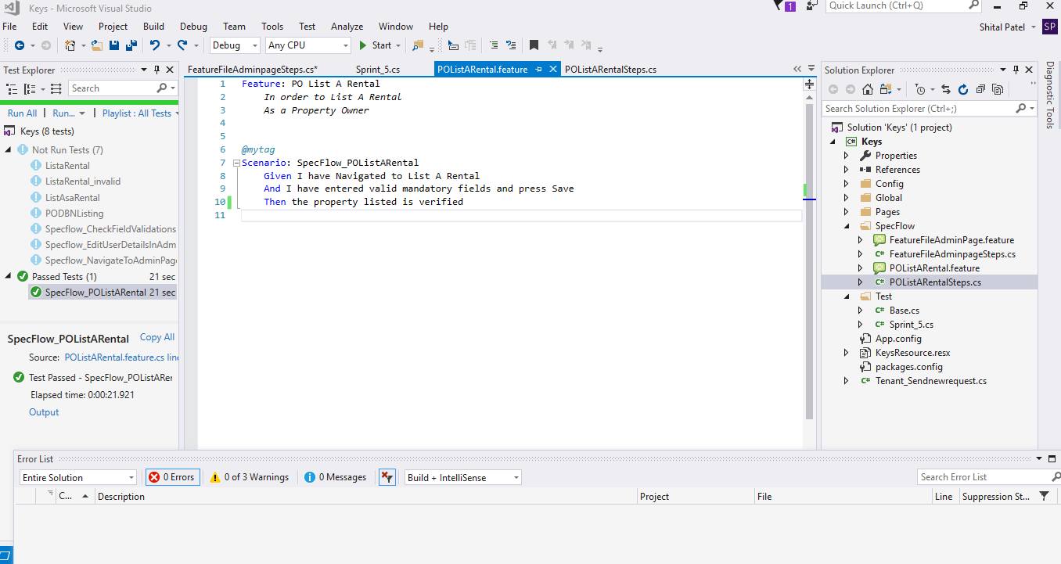

SpecFlow Feature File

Feature: PO List A Rental

*In order to List A Rental*

*As a Property Owner*

*@mytag*

Scenario: SpecFlow_POListARental

Given I have Navigated to List A Rental

And I have entered valid mandatory fields and press Save

Then the property listed is verified

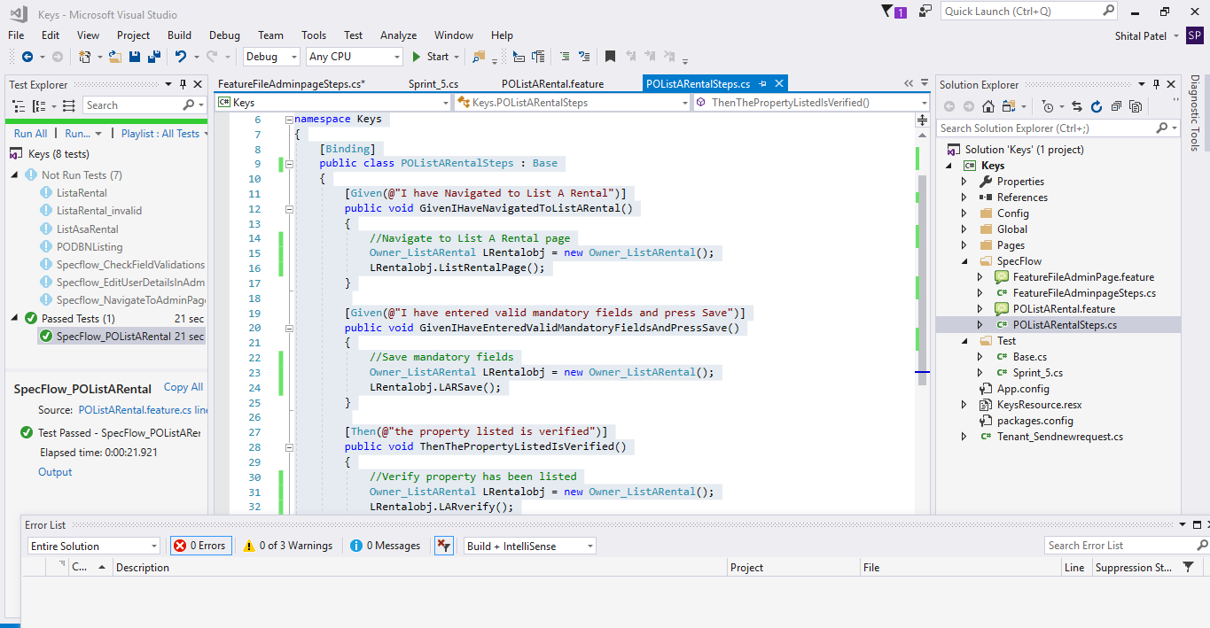

Step Generated File

using System;

using TechTalk.SpecFlow;

using Keys.Global;

using Keys.Pages;

namespace Keys

{

[Binding]

public class POListARentalSteps : Base

{

[Given(@"I have Navigated to List A Rental")]

public void GivenIHaveNavigatedToListARental()

{

//Navigate to List A Rental page

Owner_ListARental LRentalobj = new Owner_ListARental();

LRentalobj.ListRentalPage();

}

[Given(@"I have entered valid mandatory fields and press Save")]

public void GivenIHaveEnteredValidMandatoryFieldsAndPressSave()

{

//Save mandatory fields

Owner_ListARental LRentalobj = new Owner_ListARental();

LRentalobj.LARSave();

}

[Then(@"the property listed is verified")]

public void ThenThePropertyListedIsVerified()

{

//Verify property has been listed

Owner_ListARental LRentalobj = new Owner_ListARental();

LRentalobj.LARverify();

}

}

}

Output

